Installation SOP for Lighthouse

- System Overview
- Introduction
The system is a multi-functional integrated solution designed to optimize industrial operations, it combines Supply Chain Management (SRM), AI capabilities, and Energy Management (EMS).
- System Architecture
Architecture: Browser/Server Architecture
Deployment Method: Hybrid Deployment (Docker Containers + Host Machine services)
Platform: Virtualized environment via Promox
Operating System: Rocky Linux 8.10 / CentOS 7.9
- Deployment Directory Structure
The directory structure is strictly follow as below:
- /fii/application/carbon/: Contains Backend and AI source code
- /fii/application/ems/: Contains EMS platform modules
- /fii/application/infra/: Contains middleware configuration
- /fii/data/: Primary storage for databases
- /root/vietnam_casefive_backend/: Specific workspace for Vietnam regional deployment
- Deployment Objectives
- Initializing the virtual environment and system parameters
- Deploying foundational middleware via Docker.
- Configuring environment variables to ensure connectivity between backend services and databases.
- Finalizing the deployment of Frontend interfaces, AI-driven and Onmiverse modules.

- Deployment Setup: Case 1 & 3
- Environment Initialization
Initialize the system structure and optimize kernel parameters for Rocky Linux 8.10
Step 1.1: Create Directory Structure
- sh 01_make_directory_base.sh
- sh 01_make_directory_service.sh
To check the structure:
- ls /fii
Step 1.2: System Optimization
Apply system parameter modifications and reboot the server to apply changes:
- sh 01_01_system_param_modify_rocky8.10.sh
- reboot

- Docker Engine Setup
Install and configure the Docker runtime environment
Step 2.1: Install Docker
- yum install -y docker-ce docker-ce-cli containerd.io
- systemctl start docker
- systemctl enable docker
Step 2.2: Verify Installation to ensure Docker is active and running:
- docker -v
- systemctl status docker

- Image Preparation
Load the pre-packaged Docker images into the local registry.
Step 3.1: Load Service Images
Navigate to the image directory:
- cd /fii/images
Execute these load commands:
- docker load -i mysql.tar
- docker load -i redis.tar
- docker load -i nacos.tar
- docker load -i minio.tar
- docker load -i nginx.tar
- docker load -i xxl-job.tar
- docker load -i pgvector.tar
To check after loaded:
- docker images

- Middleware Deployment
Deploy foundational services required for the SRM and AI backend.
Step 4.1: MySQL Initialization
- sh 04_mysql_init_rocky8.10.sh
To verify:
- docker ps | grep mysql
- ss -tlnp | grep 3306
- docker logs -f mysql
Test login:
- mysql -uroot -p -e "SHOW DATABASES; SELECT 1;"
Step 4.2: Redis Deployment
- cd /fii/data
- unzip redis.zip
- cd redis
- sh start_redis.sh
To verify:
- docker ps | grep redis
- ss -tlnp | grep 6379
Step 4.3: Nacos, MinIO, and XXL-JOB Deployment
For Nacos:
- cd /fii/application/infra/nacos
- sh 06_nacos_deploy.sh
For MinIO:
- sh 07_minio_deploy.sh
For XXL-JOB:
- sh 08_xxl-job_deploy.sh
Step 4.4: PGVector Deployment (Vector Database for AI)
This step requires manual directory permission setup:
- mkdir -p /fii/data/database/pgdata
- chown -R 999:999 /fii/data/database/pgdata
- chmod -R 750 /fii/data/database/pgdata
- docker run -d - - name pgvector -e POSTGRES_PASSWORD=123456 -v /fii/data/database/pgdata:/var/lib/postgresql/data -p 5432:5432 pgvector/pgvector:pg16

- Backend & AI Service Configuration
Step 5.1: Configure SRM Backend
Edit the environment file to point to the correct Host IP addresses:
- cd /fii/application/carbon/backend
- vim cp.env
After that, modify these fields with the Server IP: MYSQL_HOST, REDIS_HOST, MINIO_HOST, NACOS_HOST
Step 5.2: Deploy SRM Service
- cd srm
- sh docker_srm.sh
To verify:
- docker ps | grep srm
- docker logs -f srm
Step 5.3: Configure and Start AI Service
- cd /fii/application/carbon/ai
- unzip src.zip
- vim .env
After that, update values for: PGVECTOR_URI, EMBEDDING_URL, CHAT_API_TOKEN
Step 5.4: Start AI Service
- sh start_up.sh
To verify:
- docker ps | grep ai

- Frontend Deployment
Deploy the Nginx-based web interface
- mkdir -p /opt/srm-vi-web
- cd /opt/srm-vi-web
- sh deploy.sh
Check if port 80 is listening or not:
- docker ps | grep nginx
- ss -tlnp | grep 80

- Deployment Setup: Case 2
Step 1: Access the Config Folder, at the root of the project:
- cd /opt/vi-web-02
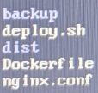
Step 2: Access configuration file using:
- vim nginx.conf
Replace the following parameters with actual data provided by the TARG technical team:
Username, Password, IP Address and Port.
Step 3: Check docker files in the gateway and main:
- From the root, cd /data/application/fm-back
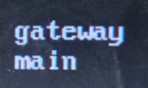
Access each of the above folder, for example gateway:
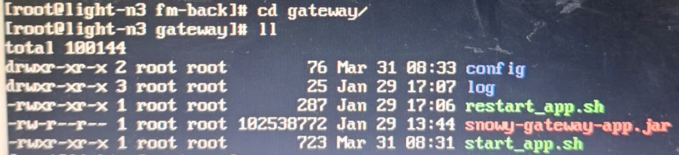
Run all sh files:
- sh restart_app.sh
- sh start_app.sh

- Deployment Setup: Case 4
- Prerequisites & Tooling
Step 1.1: Install Docker Compose:
Ensure Docker Compose (version >= 2.0) is installed:
- yum install -y docker
- systemctl enable docker && systemctl start docker
- curl -L "https://github.com/docker/compose/releases/download/2.22.0/docker-compose-$(uname -s)-$(uname -m)" -o /usr/local/bin/docker-compose
- chmod +x /usr/local/bin/docker-compose
To check the version:
- docker-compose -v
Step 1.2: Directory Structure Verification
Confirm the project root is mapped to /fii, the server's data disk should be mounted to this directory. The EMS structure should be:
- Backend: /fii/application/ems/backend
- Frontend: /fii/application/ems/frontend
- Infra: /fii/application/ems/infra
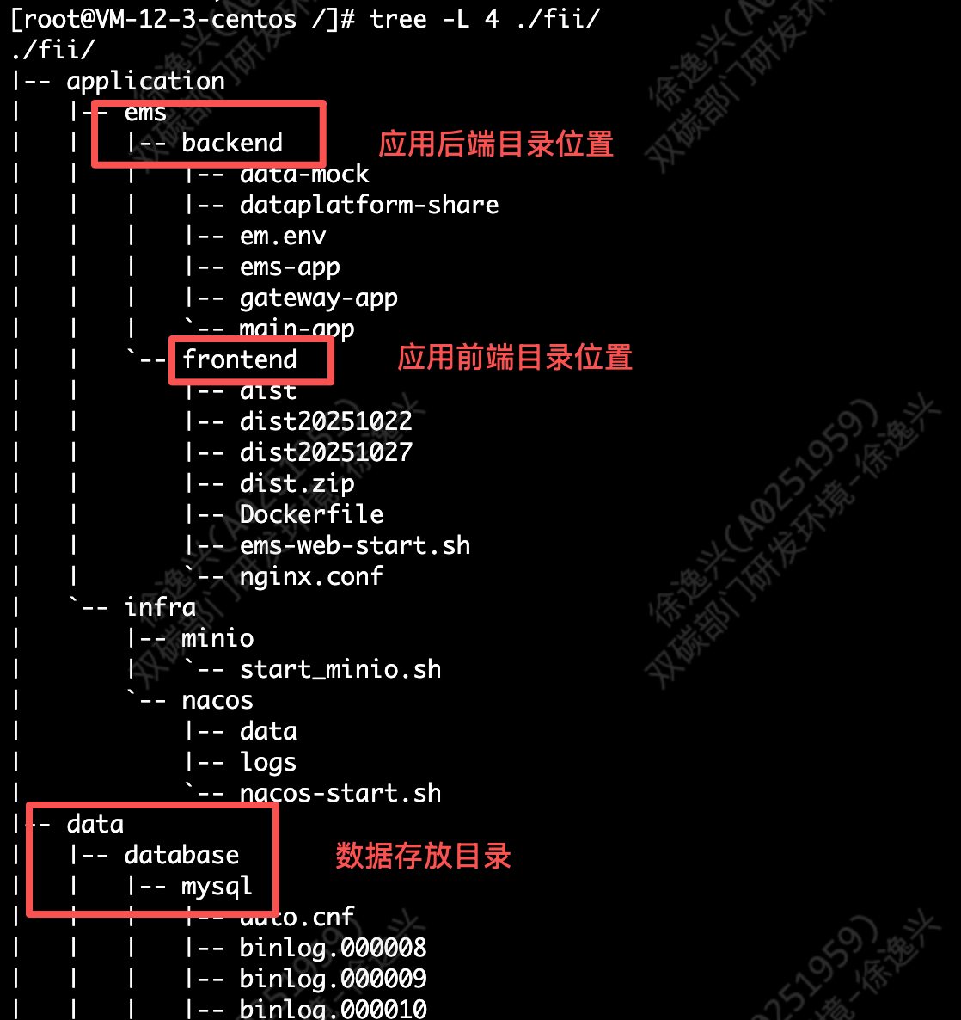
Each single application directory contains the following files:
- Configuration file: xxx.yml
- Program package: xxx.jar
- Image file: Dockerfile
- Service startup script: xxx.sh
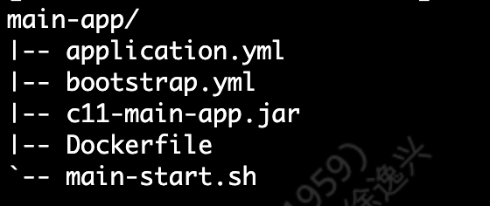

- File Preparation
Step 2.1: Upload Backend Assets
Upload all .jar files and configuration files to their respective module directories under:
- /fii/application/ems/backend/[module_name]
Step 2.2: Upload Frontend Assets
- Upload the packaged frontend dist folder or compressed file to:
/fii/application/ems/frontend
Note: Extract the file if it is compressed to create the dist directory.

- Configuration Verification
Verify the network and database connectivity settings before running services.
Step 3.1: Verify Application Configuration
Move to each backend module and check file: “application.yml”. Make sure the following IP addresses point to the correct Database/Host server:
- MySQL: spring.datasource.dynamic.datasource.master.url
- PostgreSQL (TSDB): spring.datasource.dynamic.datasource.tsdb.url
- Redis: spring.redis.host
- Nacos: spring.cloud.nacos.discovery.server-addr
- MinIO: minio.endpoint
Step 3.2: Verify Frontend Proxy
Check the Nginx configuration in the frontend directory to ensure API forwarding paths and ports are correctly mapped to the backend gateway.

- Backend Services Deployment
Deploy the backend modules
Step 4.1: Execute Deployment Scripts
For each module ems-main; ems-gateway; ems-app; data-adapter, navigate to its directory and run the deployment script:
- cd /fii/application/ems/backend/name-of-module
- sh docker .sh
Wait until execution is completed. Ensure that the required Docker image (openjdk) available beforehand.
If no errors occur, take the ems-main service as an example.
View logs:
- docker logs -fn50 ems-main
When the banner is printed, it indicates the service has started successfully.
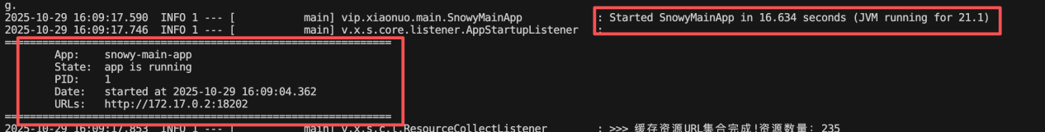
Step 4.2: Monitor Startup Logs
Check the logs to ensure the Spring Boot "Banner" appears, indicating a successful start:
- docker logs -fn50 ems-main
Look for the message: “Started [ServiceName] in [X] seconds”

- Frontend Services Deployment
Deploy the Vue + Nginx visual interface.
Step 5.1: Start Frontend Container
- cd /fii/application/ems/frontend
- sh docker.sh
If no errors occur, access the platform via browser at: <ip>ems//login
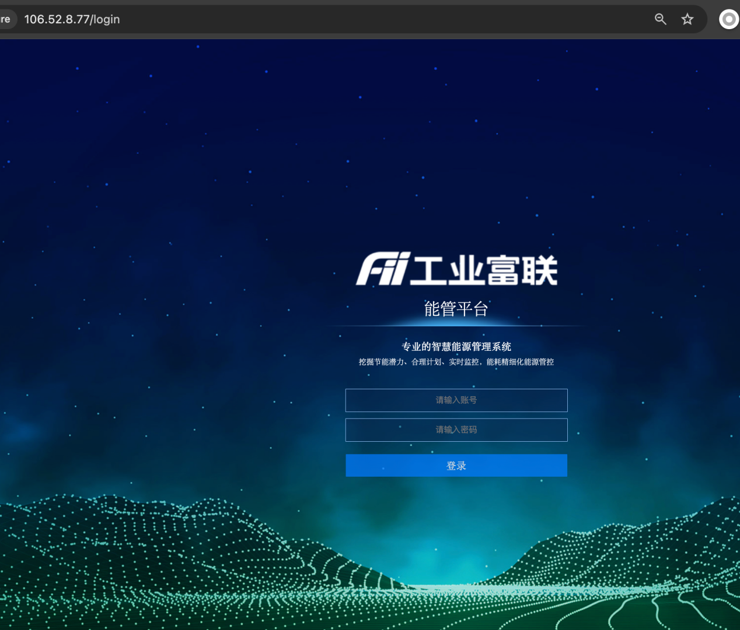

- Connectivity Verification
Check all EMS components, make sure all necessary ports are listening
- Nacos: 8848
- MinIO: 9001
- EMQX: 18083
- EMS Web: 80
Module | Test Method | Command / URL
Nacos | Open Management Page | http://<ip>:8848/nacos
MinIO | Open Console | http://<ip>:9001
EMQX | Access Dashboard | http://<ip>:18083
MySQL | Check Connectivity | mysql -uroot -p
PostgreSQL | Check Connectivity | psql -U postgres -d ems_tsdb
Redis | Check Connectivity | Redis-cli -h 127.0.0.1 ping

- Deployment Setup: Case 5
Step 1: Access the Project Folder
- cd /root/vietnam_casefive_backend/backend
Step 2: Edit the Environment File, access the environment using:
- vim power.env
Replace the following parameters with actual data provided by the TARG technical team:
Username, Password, IP Address and Port.
Step 3: Deployment
- sh docker_srm.sh
To check if the containers are running correcly:
- docker ps
Step 4: Service Restoration
If the services do not start automatically, use docker start with IDs name of 6 service containers, to see the IDs name:
- docker ps -a
- docker start [CONTAINER_ID]

